Intervertebral Disk Disease in Dogs

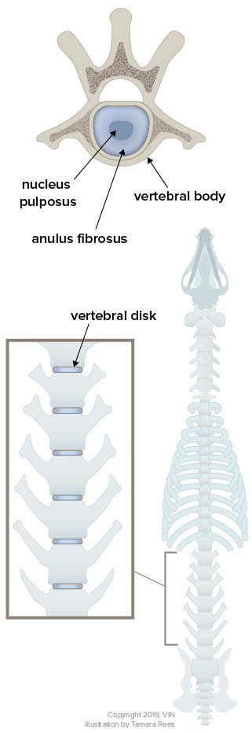
What is a Disk?
Most people are aware that the backbone is not just one long, tubular bone. The backbone (or spine) is actually made of numerous smaller bones called vertebrae that house and protect the spinal cord. The numerous vertebrae that make up the spine allow for flexibility of the back. The vertebrae are connected by joints called intervertebral disks.
The disk serves as a cushion between the vertebral bodies of the vertebrae. It consists of a fibrous outer shell (called the annulus fibrosus), a jelly-like interior (the nucleus pulposus), and cartilage caps on each side connecting it to the vertebral bones. Ligaments run below and above the discs, with the ligament above the discs being particularly rich in sensitive nerves. These ligaments are called the dorsal (above) and ventral (below) longitudinal ligaments. They run the entire length of the vertebral column.

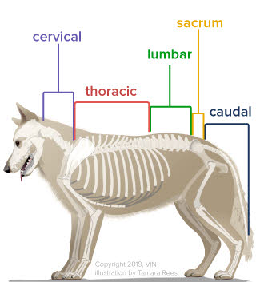
There are seven cervical (neck) vertebrae, 13 thoracic (chest) vertebrae, seven lumbar (lower back) vertebrae, three sacral vertebrae (which are fused), and a variable number of tail vertebrae.

The most common sites of disk herniation are T11 - T12 (between the 11th and 12th thoracic vertebrae) and L2 - L3 (between the 2nd and 3rd lumbar vertebrae). Cervical (neck) disk herniations occur in 15% of disk herniation patients but 80% of these patients are dachshunds, beagles, or poodles. C2 - C3 (between the 2nd and 3rd cervical vertebrae) is the most common site of disk herniation in the neck.

Symptoms of Disk Herniation
The area of the back or neck just over the disk involved is generally painful (whereas many degenerative spinal processes are not painful). In milder cases, pain at the site of the disk may be the only symptom. As inflammation increases in the spinal cord, neurologic deficits can occur. Disk herniations in the neck tend to have more pain and less dysfunction.
One of the first dysfunctions (or deficits) is the loss of what is called conscious proprioception. Conscious proprioception is the ability to perceive where one’s feet are and orient them properly. The examiner will turn the foot over so that the top of the foot is on the ground and will see if the patient replaces the foot in the proper position. Dogs with poor proprioception will scuff their toes or even occasionally fail to flip their feet while walking and will walk on the tops of their feet. Nerves responsible for conscious proprioception are located on the outside of the spinal cord so when the disk herniates, these nerves feel the pressure first.
After the nerves that affect conscious proprioception go, next are the nerves for voluntary motion (including voluntary control of urination/defecation), followed by the nerves for superficial pain perception, and ultimately the nerves for deep pain perception (usually tested by applying a strong pinch to the toe).
Diagnostics
When presented with a patient with spinal weakness, it is important to determine whether the problem involves spinal cord compression because compressive lesions can benefit from surgery/anti-inflammatories while other diseases cannot. A compressive lesion in the spinal cord does not have to be a disk herniation; it could be a vertebral fracture or dislocation, a tumor, or a disk infection.
A non-compressive lesion will not benefit from surgery. Such lesions include: spinal degeneration, spinal infection or inflammation, demyelination injuries, or fibrocartilaginous embolism. These patients usually present in excruciating pain while herniated disk patients are usually less painful on palpation.
Step One: The Neurologic Examination
Localize the lesion through a series of reflex testing, proprioception, and physical examination.
Step Two: Plain Radiographs
While advanced modes of imaging such as magnetic resonance imaging (MRI) and computed tomography (CT) scanning are not available to most veterinary hospitals, plain radiography usually is. It is also relatively inexpensive compared to other forms of imaging. If vertebral trauma, bone tumors, or calcified disks are suspected radiographs can be beneficial.

Step Three: Advanced Imaging
If surgery is being considered, then it becomes necessary to identify the exact disk space involved so that the surgeon will know where to cut. A myelogram is usually performed at the time of advanced imaging. Myelography requires general anesthesia and the injection of iodine based dye around the spinal cord. The image of the dye can be seen to narrow at the area of spinal cord compression identifying the area of compression in 85-95% of cases. The patient typically then goes directly to surgery without waking from anesthesia. As a general rule, there is not much point in performing a procedure to specifically localize a compressive lesion unless surgery is being considered.
As CT becomes more available, a scan is often performed in addition to or instead of a myelogram. This gives an even more accurate image of the disk herniation and its location, as well as whether there is more than one disk involved.
Treatment
Based on initial examination and diagnostics a decision must be made as to whether or not surgery should be pursued vs medical management trial. Spinal surgery is very expensive and requires a long recovery period but may be the best choice if the dog is to regain normal function. There are some general rules that are typically applied in making this decision, and they are based on pain and function:
- If the dog can walk, medical (non-surgical) treatment is a reasonable choice but this also depends on how much pain the patient is in, how long the patient has had signs, and what sort of treatments have been unsuccessful in the past. Medical management is a good option for mild clinical signs who are not in excruciating pain.
- The longer the neurologic deficits have been going on, the poorer the results of treatment. If caught early, medical management is a reasonable choice.
- If the dog cannot walk but has deep pain in at least one limb, there is a 83-93% success rate for recovery with surgery.
- If the dog has been unable to walk, has no deep pain perception in the limbs but has only been down less than 48 hours, success with surgery drops to 50-60%. After 48 hours in this situation, prognosis is much worse and it may not be worth considering surgery.
- If the dog cannot walk, medical management may still have success although surgery is definitely more likely to yield success. Furthermore, return to walking may take months with medical management vs. a few weeks with surgery.

Losing the ability to walk is an emergency. Do not wait to see if it gets better; go to the vet at once!

Medical/Conservative Treatment (No Surgery)
While medication can be used to assist in recovery, the centerpiece of therapy is confinement. Confinement must be strict, which means a cage or kennel must be provided. This will be difficult as the dog will typically not want to be isolated and may cry or fuss. An owner will be tempted to say that the painful dog will confine himself. In reality, poor results in a dog are almost always traceable to inadequate confinement and if cage rest is not possible at home, consider boarding the dog at the veterinary hospital to ensure proper rest. The dog can be walked (or carried) outside to urinate and defecate but then must be walked (or carried) right back in.
Three weeks of cage rest is a minimum course. After this time, the patient can take another 2 to 3 weeks to gradually resume normal activity.
Medications typically accompany confinement. Steroids, non-steroidal anti-inflammatories, and pain relievers are commonly prescribed. Therapeutic laser or acupuncture may aid in recovery.
Physical Therapy Exercises During the First 3 to 4 Weeks of Confinement
- Massage the area gently to improve circulation to the area. This is done as many times a day as possible during the first 3 to 5 days and after that drop to three times daily.
- Sensory input is important caudal (towards the tail) to the spinal lesion. This entails tickling and pinching the toes. A withdraw reflex should be elicited (pull the leg towards the body). The idea is to make the dog aware of the feet.
Physical Therapy Exercises after the Initial 3 to 4 Weeks Confinement Period or with more Chronic Disk Cases
- Stand the dog up and see how long it takes before he has to sit or lie down. Do not push the dog to exhaustion. For example, if he sits after 30 seconds then the standing exercise should be 20 seconds. Assist standing as needed.
- Stand the dog and gently push him to one side but not so much that they fall. Do five repetitions, three times a day. This is a balance exercise.
- Have the dog sit and then stand. Do five repetitions, three times a day. This is a strengthening exercise.
- Walk the dog on lumpy ground. An obstacle course can be made by putting broomsticks or a ladder on the ground, setting up a wastebasket to walk around etc. The dog should be walked through this three times daily.
- Flexibility exercise involves 60 very small food treats. The dog is standing; assist if needed. Hold the treat up (skyward) so the dog must reach for the treat. This is done 15 times. Hold the treat down at chest level so the dog must reach down for the treat. This is done 15 times. Hold the treat just at the shoulder blade so the dog must reach for it. This is done 15 times on the right and 15 times on the left. Hold the treat back at the level of the hip so the dog must reach around for the treat. This is done 15 times for the right and 15 times for the left.
The dog should at no time be left free to run and jump during the recovery period, even if he seems to be feeling good. Agility, jumping and fetching games or other performance activities are best removed from the dog's lifestyle permanently lest another disk herniate.
Patients who have suddenly lost the ability to walk may be treated conservatively as above but their best chance at regaining the ability to walk is with surgery. Conservative management works best for dogs that are able to walk, have pain perception in their feet, and have both urinary and fecal continence.
Physical therapy for pets is a relatively new field of specialization and we are finding that rehabilitation exercises make a huge difference to patient comfort and ability in many situations. Ask your veterinarian about a referral.
Surgery
Hemilaminectomy
This is most commonly performed on disk herniations in the thoracolumbar area. In this surgery the articular facets (where the two vertebrae connect) are removed, as is the vertebral bone adjacent to the spinal cord. This procedure can safely be performed over up to five adjacent disk spaces.

Ventral Slot
This procedure is reserved for neck disks. Here a slot is drilled in the vertebral bodies of the bones on either side of the disk creating a small window over the disk space. Mineralized disk material can be removed and, since the window includes adjacent bone, there is room for the swollen spinal cord to decompress.

Recovery after Surgery
The goal of surgery is to restore the pet's quality of life. In most cases this means return of the ability to walk. How long it takes the patient to walk again after surgery is highly dependent on how much dysfunction the dog had prior to surgery. Patients with voluntary motor control commonly recovery the ability to walk within 2 weeks while those with deep pain but no voluntary motor control might require up to 4 weeks. Nursing care for a dog that cannot walk can be intense, including expressing the patient's bladder, keeping the patient bedded, and performing physical therapy exercises. Check with your surgeon regarding the exercises listed above as to which might be recommended for your particular pet.

When the Pet is not Expected to Walk
Taking care of a dog that is down in back is a big project, and definitely not something that every dog owner is able to commit to. Still, it can be done and for the right dog and the right person, it is a highly rewarding experience. A great deal of progress can often be made using physical therapy exercises as described in the medical management section, plus there are a number of resources and products available to assist caring for an immobile pet.

